**Chesapeake Community Connect Website: Americans with Disabilities Act Compliance Specification**

**COSC401: Software Startup Simulator**

**October 21, 2024**

**Version 1.0**

**Written By: Oliver Meyer**

**Project Supervisor: Leah Carroll**

# Table of Contents

**Table of Contents 1**

**1. Introduction 2**

1.1 Purpose 2

1.2 Scope 2

1.3 Definitions, Acronyms, and Abbreviations 2

1.4 Document References 3

1.5 Tools 3

**2. Percievable 3**

2.1 Text 3

2.1.1 Text Contrast 3

2.1.2 Text Size 3

2.1.3 Text Style 3

2.1.4 Font 3

2.1.5 Spacing 3

2.2 Non-Text Content 4

2.2.1 Text Alternatives 4

2.2.2 Captions 4

2.2.3 Audio Description 4

**3. Operable 4**

3.1 Keyboard Operability 4

3.1.1 Keyboard Accessibility 4

3.1.2 No Keyboard Trap 5

3.1.3 Character Key Shortcuts 5

3.2 Seizure Awareness 5

3.3 Navigable 5

3.3.1 Page Titles 5

3.3.2 Link Purpose 5

3.3.3 Multiple Ways 5

3.3.4 Headings and Labels 5

**4. Understandable 5**

4.1 Language of Page and Parts 6

4.2 Predictable 6

4.2.1 Consistent Navigation 6

4.2.2 Consistent Identification 6

4.3 Input Assistance 6

4.3.1 Error Identification 6

4.3.2 Labels or Instructions 6

4.3.3 Error Suggestion 6

**5. Robust 6**

5.1 Parsing 6

5.2 Name, Role, Value 7

**6. CCC Website 7**

6.1 Percievable 7

6.2 Operable 8

6.3 Understandable 8

6.4 Robust 8

6.4.1 ARIA 8

# 

# 1. Introduction

When considering website design, it is important to prioritize inclusivity- making the website available to use for all, regardless of physical ability, sensory impairment, cognitive differences, or technological limitations. Guidelines have been created thanks to the Americans with Disabilities Act (ADA) to produce an objective standard of design used to measure to level of accessibility that a site meets, thus protecting people with disabilities from discrimination.

## 1.1 Purpose

The purpose of this report is to summarize website specifications laid out by the ADA, and apply them to the Chesapeake Community Connect (CCC) website. This document serves as a guide for developers and designers, detailing the considerations necessary to meet AA accessibility standards.

## 1.2 Scope

This document covers key aspects of the website’s UI, as well as backend features, that affect accessibility.

This document is written in accordance with the Web Content Accessibility Guidelines (WCAG).

There are three levels of accordance laid out by the WCAG, from A to AAA, with AAA being the most intensive. This document is made to reference specifications compliant with the AA level of accordance. To meet AA criteria, the criteria for both the A and AA levels must be met fully.

Some irrelevant requirements are not included in this document, such as those regarding the handling of sensitive financial information.

## 

## 1.3 Definitions, Acronyms, and Abbreviations

| Acronym | Meaning |
| --- | --- |
| ADA | Americans with Disabilities Act |
| AG WG | Accessibility Guidelines Working Group |
| ARIA | Accessible Rich Internet Applications |
| CCC | Chesapeake Community Connect |
| EOWG | Education and Outreach Working Group |
| ID | Identification |
| WCAG | Web Content Accessibility Guidelines |
| WCAG WG | Web Content Accessibility Guidelines Working Group |

## 

## 1.4 Document References

| Document Title | Date | Authors |
| --- | --- | --- |
| WCAG 2.2 Understanding Docs | June 6, 2024 | AG WG |
| How to Meet WCAG | October 3, 2024 | EOWG, WCAG WG |

## 

## 1.5 Tools

A list of general website accessibility testing tools is included below:

<https://www.w3.org/WAI/test-evaluate/tools/list/>

# 2. Percievable

Information and user interface components must be presentable to users in ways they can perceive.

## 2.1 Text

This section outlines requirements dealing with written words.

### 2.1.1 Text Contrast

The visual presentation of text and images of text has a contrast ratio of at least 4.5:1, except for the following:

* Large Text: Large-scale text and images of large-scale text have a contrast ratio of at least 3:1. Large text is at least 18 point, or 14 point bold.
* Incidental: Text or images of text that are part of an inactive user interface component, that are pure decoration, that are not visible to anyone, or that are part of a picture that contains significant other visual content, have no contrast requirement.
* Logotypes: Text that is part of a logo or brand name has no minimum contrast requirement.

<https://www.w3.org/WAI/WCAG22/Understanding/contrast-minimum.html>

### 2.1.2 Text Size

Except for captions and images of text, text can be resized without assistive technology up to 200 percent without loss of content or functionality.

<https://www.w3.org/WAI/WCAG22/Understanding/resize-text.html>

### 2.1.3 Text Style

Italics should not be used whenever possible for readability. Instead, bolding should be used to add emphasis.

### 2.1.4 Font

There is a wide and diverse selection of fonts out there. To adhere to ADA compliance, it is best to stick to simple, well-known fonts with high readability. Examples include Times New Roman, Verdana, Cabri, Helvetica, and Tahoma.

### 2.1.5 Spacing

Webpage text must have the ability to be set to the following metrics without loss of content or function:

* Line height (line spacing) to at least 1.5 times the font size;
* Spacing following paragraphs to at least 2 times the font size;
* Letter spacing (tracking) to at least 0.12 times the font size;
* Word spacing to at least 0.16 times the font size.

Note: This guideline does not require that text on the website meet these format specifications, only that no loss of functionality results when setting the text to the properties outlined.

<https://www.w3.org/WAI/WCAG22/Understanding/text-spacing.html>

## 

## 2.2 Non-Text Content

This section outlines requirements dealing with non-text content, such as pictures or videos.

### 2.2.1 Text Alternatives

All non-text content that is presented to the user has a text alternative that serves the equivalent purpose, except for the situations listed below.

* Controls, Input: If non-text content is a control or accepts user input, then it has a name that describes its purpose
* Time-Based Media: If non-text content is time-based media, then text alternatives at least provide descriptive identification of the non-text content.
* Decoration, Formatting, Invisible: If non-text content is pure decoration, is used only for visual formatting, or is not presented to users, then it is implemented in a way that it can be ignored by assistive technology.

<https://www.w3.org/WAI/WCAG22/Understanding/non-text-content.html>

### 2.2.2 Captions

Captions are provided for all prerecorded audio content in synchronized media.

<https://www.w3.org/WAI/WCAG22/Understanding/captions-prerecorded.html>

### 2.2.3 Audio Description

Audio description is provided for all prerecorded video content in synchronized media.

<https://www.w3.org/WAI/WCAG22/Understanding/audio-description-prerecorded.html>

# 3. Operable

User interface components and navigation must be operable.

## 3.1 Keyboard Operability

This section outlines requirements dealing with keyboard function.

### 3.1.1 Keyboard Accessibility

All functionality of the content is operable through a keyboard interface without requiring specific timings for individual keystrokes, except where the underlying function requires input that depends on the path of the user's movement and not just the endpoints.

<https://www.w3.org/WAI/WCAG22/Understanding/keyboard.html>

### 3.1.2 No Keyboard Trap

If keyboard focus can be moved to a component of the page using a keyboard interface, then focus can be moved away from that component using only a keyboard interface.

<https://www.w3.org/WAI/WCAG22/Understanding/no-keyboard-trap.html>

### 

### 3.1.3 Character Key Shortcuts

If a keyboard shortcut is implemented in content using only letter (including upper- and lower-case letters), punctuation, number, or symbol characters, then at least one of the following is true:

* Turn off: A mechanism is available to turn the shortcut off;
* Remap: A mechanism is available to remap the shortcut to include one or more non-printable keyboard keys (e.g., Ctrl, Alt);
* Active only on focus: The keyboard shortcut for a user interface component is only active when that component has focus.

<https://www.w3.org/WAI/WCAG22/Understanding/character-key-shortcuts.html>

## 3.2 Seizure Awareness

Web pages do not contain content that flashes more than three times in a one second period.

<https://www.w3.org/WAI/WCAG22/Understanding/three-flashes-or-below-threshold.html>

## 3.3 Navigable

### 3.3.1 Page Titles

Web pages have titles that describe topic or purpose.

<https://www.w3.org/WAI/WCAG22/Understanding/page-titled.html>

### 3.3.2 Link Purpose

The purpose of each link can be determined from the link text alone.

<https://www.w3.org/WAI/WCAG22/Understanding/link-purpose-in-context.html>

### 3.3.3 Multiple Ways

More than one way is available to locate a Web page within a set of Web pages.

<https://www.w3.org/WAI/WCAG22/Understanding/multiple-ways.html>

### 3.3.4 Headings and Labels

Headings and labels describe topic or purpose.

<https://www.w3.org/WAI/WCAG22/Understanding/headings-and-labels.html>

# 4. Understandable

Information and the operation of the user interface must be understandable.

## 4.1 Language of Page and Parts

The default human language of each Web page, along with each passage and phrase within, can be programmatically determined.

<https://www.w3.org/WAI/WCAG22/Understanding/language-of-page.html>

<https://www.w3.org/WAI/WCAG22/Understanding/language-of-parts.html>

## 4.2 Predictable

### 4.2.1 Consistent Navigation

Navigational mechanisms that are repeated on multiple Web pages within a set of Web pages occur in the same relative order each time they are repeated, unless a change is initiated by the user.

<https://www.w3.org/WAI/WCAG22/Understanding/consistent-navigation.html>

### 4.2.2 Consistent Identification

Components that have the same functionality within a set of Web pages are identified consistently.

<https://www.w3.org/WAI/WCAG22/Understanding/consistent-identification.html>

## 

## 4.3 Input Assistance

### 4.3.1 Error Identification

If an input error is automatically detected, the item that is in error is identified and the error is described to the user in text.

<https://www.w3.org/WAI/WCAG22/Understanding/error-identification.html>

### 4.3.2 Labels or Instructions

Labels or instructions are provided when content requires user input.

<https://www.w3.org/WAI/WCAG22/Understanding/labels-or-instructions.html>

### 4.3.3 Error Suggestion

If an input error is automatically detected and suggestions for correction are known, then the suggestions are provided to the user, unless it would jeopardize the security or purpose of the content.

<https://www.w3.org/WAI/WCAG22/Understanding/error-suggestion.html>

# 5. Robust

Content must be robust enough that it can be interpreted by a wide variety of user agents, including assistive technologies.

## 5.1 Parsing

In content implemented using markup languages, elements have complete start and end tags, elements are nested according to their specifications, elements do not contain duplicate attributes, and any IDs are unique, except where the specifications allow these features.

<https://www.w3.org/WAI/WCAG22/Understanding/parsing.html>

## 

## 5.2 Name, Role, Value

For all user interface components (including but not limited to: form elements, links and components generated by scripts), the name and role can be programmatically determined- make sure they are accessible using ARIA roles and states.

<https://www.w3.org/WAI/WCAG22/Understanding/name-role-value.html>

# 6. CCC Website

This sections lays out necessary steps in order for the CCC website to be ADA compliant.

## 6.1 Percievable

Make sure all text meets the minimum contrast requirements laid out in section 2.2.1. The image below is an example of insufficient contrast in the “Keyboard shortcuts” menu.

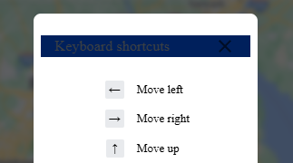

Image Description: A popup menu with the title “Keyboard shortcuts”, dark gray text against a dark blue background.

Resources to check contrast:

<https://accessibleweb.com/color-contrast-checker/>

<https://webaim.org/resources/contrastchecker/>

Ensure the specifications for non-text content are met as well. Although the video shown in the screenshot below has a description, there are no captions or audio description, as laid out in sections 2.2.2 - 2.2.3.

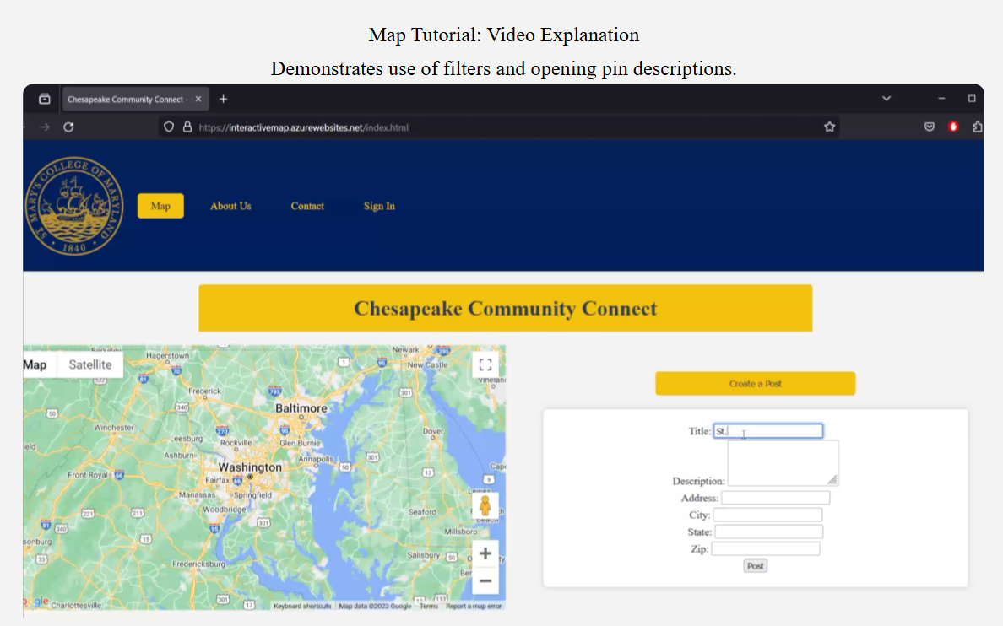

Image Description: A screenshot of a video embedded in the “Map” page. The video contains no options for captions or an audio description.

Ensure all images (including images of text) have compliant alternative text, as outlined here:

<https://www.w3.org/TR/UNDERSTANDING-WCAG20/conformance.html#uc-text-alternatives-head>

## 6.2 Operable

Ensure all website functions are operable using only a keyboard, not requiring a mouse or any specific keystroke timing. Ensure all web pages have clear, informative titles. The link in section 3.3.1 provides more information about how titles work.

## 6.3 Understandable

Keep navigation and component identification consistent.

## 6.4 Robust

Make sure ARIA labels are utilized throughout the website whenever necessary.

### 6.4.1 ARIA

Intro to ARIA labels:

<https://developer.mozilla.org/en-US/docs/Learn/Accessibility/WAI-ARIA_basics>

<https://www.w3.org/TR/WCAG20-TECHS/wai-aria_notes.html>

Techniques with examples:

<https://www.w3.org/TR/WCAG20-TECHS/ARIA1.html>

ARIA DevTools, will check ARIA roles: <https://github.com/ziolko/aria-devtools>

“With ARIA DevTools you see your website the way screen readers present it to the blind users. All page elements are presented according to their explicit or implied ARIA roles. This includes headings, images, tables and form items beyond others. It's now easy to spot missing ARIA labels, misused ARIA roles, and incomplete keyboard support.”

Total Validator, will check for general accessibility, including ARIA: <https://www.totalvalidator.com/>

“Checks websites are accessible, use valid HTML, ARIA and CSS, have no broken links, and are free from spelling mistakes. Test single pages through to multiple websites in one go; including offline, authenticated, and javascript generated pages.”